SOFTWARE ENGINEERING-INTRODUCTION TO MY PROJECT
1. Name
Project Name: Medicare Hospital Management Website
The name of our project is Medicare Hospital. It is a hospital website designed to provide patients with information about hospital services, doctors, and appointments. The website provides an easy way for patients to interact with the hospital and find the required healthcare information.
2. Background
Hospitals provide many healthcare services, but patients often need to visit the hospital or call to get basic information about doctors, services, and appointments.
The Medicare Hospital website is designed to provide this information online. Patients can view available services, learn about doctors, and enter their appointment details through the website.
The project is based on the idea of making hospital information easily accessible, organized, and user-friendly.
3. Objective
The main objective of the Medicare Hospital website is to create a simple and user-friendly online hospital system.
The objectives are:
>To provide information about hospital services.
>To allow patients to enter appointment details.
>To provide information about doctors and their specialties.
>To make hospital information available online.
>To create an attractive and easy-to-use interface.
>To reduce the need for patients to visit the hospital just to obtain basic information.
4. Stakeholders
Stakeholders are the people or groups who use the system or are affected by it.
For our Medicare Hospital website, the main stakeholders are:
1. Patients
Patients use the website to view hospital services, doctors, and appointment information.
2. Doctors
Doctors are represented on the website with their names and specializations. They are involved in providing medical services to patients.
3. Hospital Administration
The administration manages hospital information, services, doctors, and appointment-related information.
4. Receptionist / Appointment Staff
They can use appointment information to manage patient appointments and schedules.
5. Hospital Management
Hospital management is responsible for overseeing the overall operation and services of the hospital.
5. Requirements
Requirements describe what the website needs to provide and what users need from the system.
Functional Requirements
Functional requirements describe the functions/features of the website.
For our website:
Home Page
The website should provide a home page containing basic information about Medicare Hospital.
Appointment System
Patients should be able to enter their:
>Patient name
>Phone number
>Reason for appointment
>Date and time
Hospital Services
The website should display services such as:
>Maternity Services
>Surgical Procedures
>Gynecological Services
>Cardiology Services
>Orthopedic Services
Doctors Section
The website should provide information about doctors and their specialties.
About Us
The website should provide information about the hospital.
Contact Information
The website should provide hospital contact details.
Non-Functional Requirements
These describe how the system should work, rather than specific features.
User-friendly: The website should be easy to understand and navigate.
Responsive: It should work properly on different screen sizes.
Fast: Pages should load quickly.
Secure: Patient information should be protected.
Reliable: The website should work consistently.
Attractive: The interface should have a professional hospital-themed design

HOME PAGE:
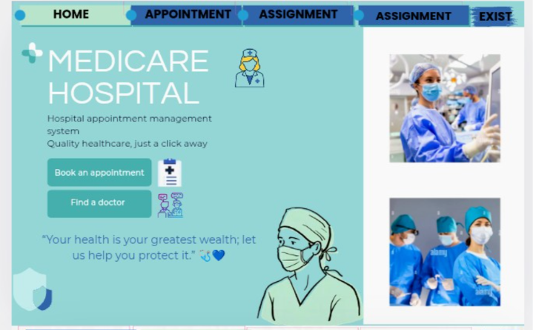

HOSPITAL SERVICES AND DETAILS OF PATIENT
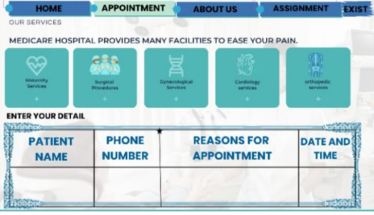
DOCTOR SECTIONS:

ABOUT US:
